**COVID -19 ANALAYSIS**

**DEVELOPMENT PART 1**

|  |  |
| --- | --- |
| **Date** | **10-10-2023** |
| **Team ID** | **720** |
| **Project Name** | **Covid-19 Cases Analysis** |

**Table of Contents**

|  |  |
| --- | --- |
| 1 | Introduction |
| 2 | Problem Statement |
| 3 | Steps involved in model evaluation |
| 3.1 | Data collection |
| 3.2 | Load the dataset |
| 3.3 | Data preprocessing |
| 3.4 | Data visualisation using Cognos |
| 8 | Conclusion |

**1. Introduction**

COVID-19, also known as Coronavirus Disease 2019, is a highly contagious respiratory illness caused by the novel coronavirus SARS-CoV-2. It emerged in late 2019 in Wuhan, China, and swiftly evolved into a global pandemic. The virus spreads primarily through respiratory droplets, leading to a wide range of symptoms, from mild respiratory issues to severe pneumonia and, in some cases, fatalities. The pandemic has had a profound impact on public health, economies, and daily life worldwide, prompting governments and healthcare systems to implement extensive measures such as lockdowns, mask mandates, and vaccination campaigns to control its spread. The ongoing battle against COVID-19 has underscored the importance of scientific research, international cooperation, and public health measures to combat emerging infectious diseases.

**2. Problem Statement**

The project involves analyzing COVID-19 cases and deaths data using IBM Cognos. The objective is to compare and contrast the mean values and standard deviations of cases and associated deaths per day and by country in the EU/EEA. This project encompasses defining analysis objectives, collecting COVID-19 data, designing relevant visualizations in IBM Cognos, and deriving insights from the data.

**3. Steps involved in model evaluation**

**3.1. Data collection:**

The dataset is intended for the analysis of COVID-19 data, focusing on the months of March, April, and May in the year 2021. It comprises columns for date, cases, deaths, and information about countries and regions within the European Union (EU) and the European Economic Area (EEA).

**3.2. Load the dataset.**

Import the necessary dependencies and load the dataset.

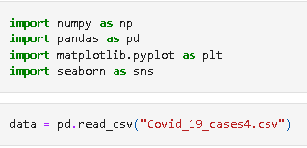

**3.3. Explore the dataset using jupyter notebook.**

**Step 1:**

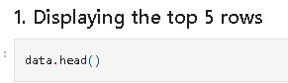

**Step 2:**

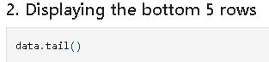

**Step 3:**

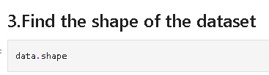

**Step 4:**

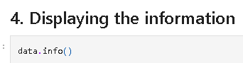

**Step 5:**

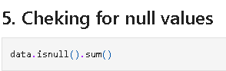

**Step 6:**

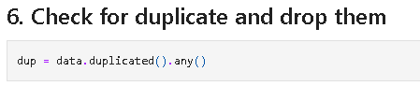

**Step 7:**

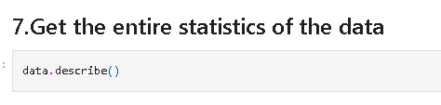

**3.4 Visualisation using Cognos:**

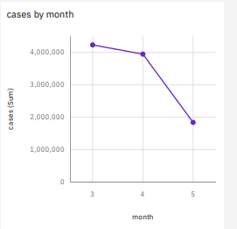 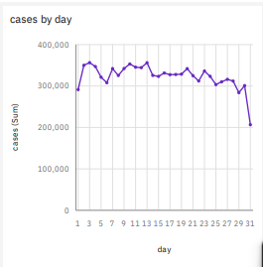

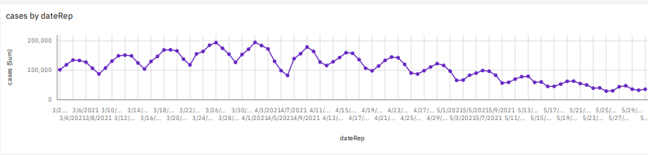

**4. Conclusion**

In conclusion, the analysis reveals a clear trend in the progression of COVID-19 cases. By closely monitoring daily variations, it becomes evident whether cases are on the rise or decline. These insights can be instrumental in making informed decisions and implementing appropriate measures to manage the pandemic effectively. The combination of preprocessing techniques and data visualization through Cognos contributes to a more comprehensive understanding of the COVID-19 situation, aiding in the development of strategies to combat the virus.